Lab Details

Running an NGINX Web Server in a Docker Container

Overview of This Lab
In this lab, you will learn how to set up and run an NGINX web server inside a Docker container using Puku CLI. You will use the integrated terminal in Puku CLI to execute Docker commands, manage containers, and configure an NGINX web server.
By the end of this lab, you will understand how Docker simplifies application deployment by providing a lightweight, portable, and scalable environment for hosting web applications.

What You'll Learn
- Use Docker commands in the Puku CLI integrated terminal to pull images, run containers, and manage container configurations.
- Deploy an NGINX web server inside a Docker container.
- Start, stop, restart, and remove Docker containers.
- View and analyze container logs for monitoring and troubleshooting.

Lab start

Running an NGINX Web Server in a Docker Container
In today's DevOps and cloud-native world, the ability to quickly deploy services in isolated environments is essential. Docker makes this possible by providing lightweight, portable containers. In this lab, you will use Puku CLI and its integrated terminal to build, run, and manage an NGINX web server inside a Docker container.
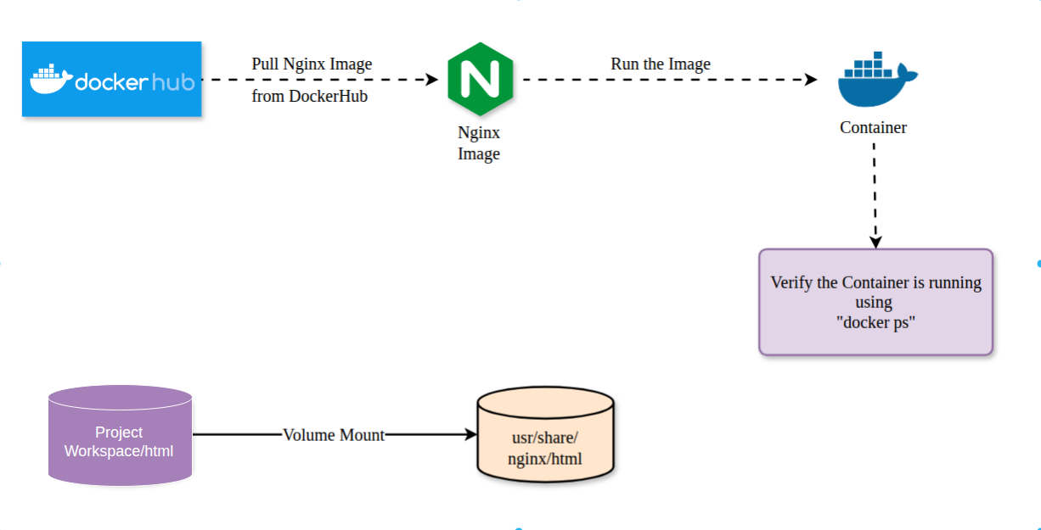
This lab will guide you through the complete process of running an NGINX web server inside a Docker container using Puku CLI. You will learn how to pull the official NGINX Docker image, create a custom HTML page, configure a volume mount, run the container, and verify that the web server is running successfully.

Lab Overview
In this lab, you will:
- Understand the basics of Docker and NGINX.
- Pull the official NGINX Docker image.
- Create and serve a custom HTML page from a Docker container.
- Map ports and mount volumes between your local project workspace and the Docker container.
- Manage the container lifecycle using the Puku CLI integrated terminal (start, stop, view logs, and remove containers).

Concepts Explained
Before starting the lab, let's understand the key technologies used.

What is Docker?
Docker is a containerization platform that packages applications and their dependencies into containers. These containers are lightweight, portable, and provide a consistent runtime environment across different systems.

What is NGINX?
NGINX is a high-performance web server that serves web content efficiently. It can also function as a reverse proxy, load balancer, and HTTP cache, making it a popular choice for hosting modern web applications.

Docker Image vs. Container
- Image: A read-only template that contains everything needed to run an application (for example, the official NGINX image).
- Container: A running instance of an image with its own isolated filesystem, processes, and networking.

Hands-on: Running NGINX in Docker
In the following exercises, you will use the Puku CLI integrated terminal to pull the official NGINX Docker image, run it as a container, and manage it using Docker commands.
Yes, exactly. Since you're actually running the commands in Puku CLI, your documentation should say Puku CLI, not AWS Terminal. The commands remain the same.
Here's a professional version for your docs:

Step 1: Pull the Official NGINX Docker Image
Open Puku CLI and launch the integrated terminal.
Run the following command to download the latest official NGINX image from Docker Hub:
docker pull nginx

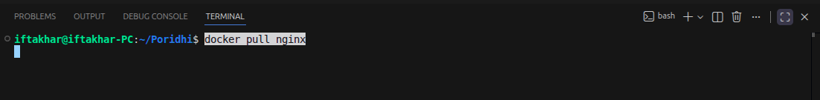

Docker will download the required image layers. Once the download is complete, the latest NGINX image will be available on your local machine.
Expected Output
You should see output similar to the following in the Puku CLI terminal:
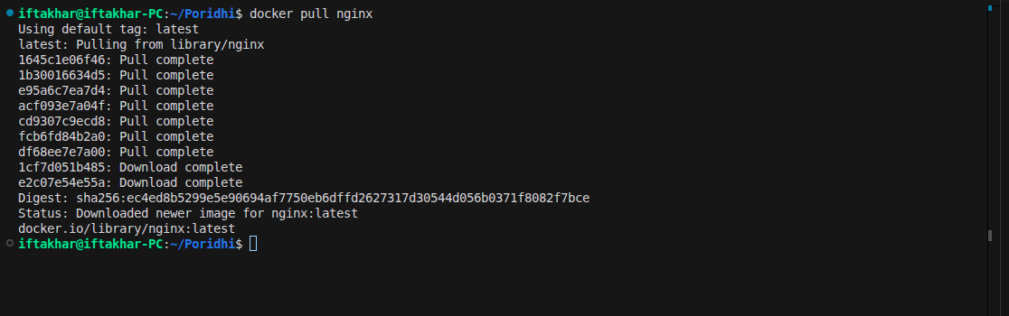

Verify the Download
To confirm that the image has been downloaded successfully, run:
docker images

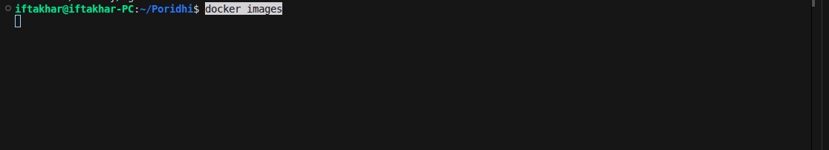
Expected Output
The command should list the nginx image with the latest tag.
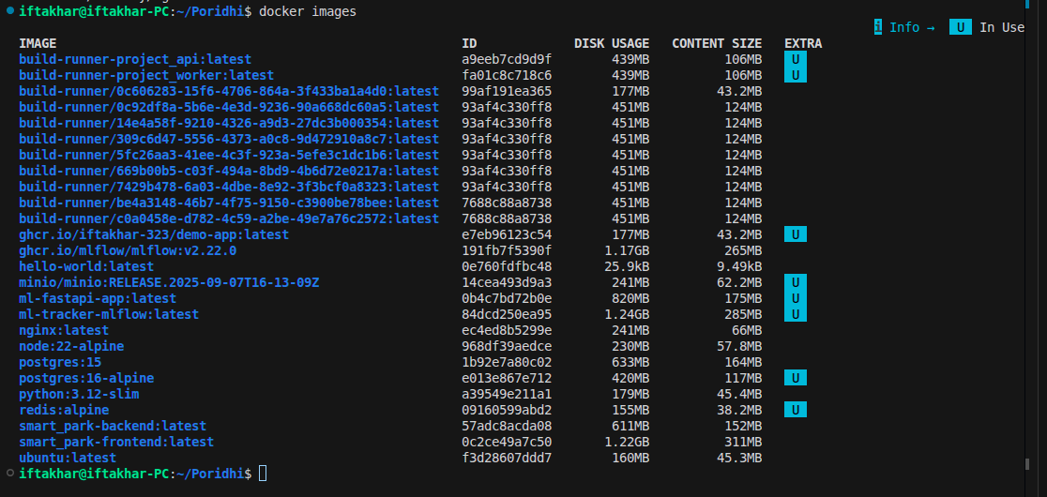

This format is much cleaner because the screenshots you capture from Puku CLI will naturally match the text in your documentation.
Here's the Puku CLI version with only the necessary changes. The commands stay the same except for the project path.

Step 2: Create a Directory for Web Content
Open the Puku CLI integrated terminal and create a directory to store your custom HTML content. This directory will later be mounted into the NGINX container.

This directory will act as the source for the web content served by the NGINX container, allowing you to update files without modifying the container itself.

Step 3: Create a Simple Web Page
Create a simple HTML page inside the html directory by running the following command:

This page will be served by the NGINX web server once the container is running.

Step 4: Run the NGINX Container
From the Puku CLI integrated terminal, run the following command:

Note: On Windows PowerShell, replace $(pwd) with ${PWD} if required.

Command Breakdown
- --name my-nginx – Assigns the name my-nginx to the container.
- -v $(pwd)/nginx-lab/html:/usr/share/nginx/html:ro – Mounts your local HTML directory into the container's web root in read-only mode.
- -p 8000:80 – Maps port 8000 on your machine to port 80 inside the container.
- -d nginx – Runs the NGINX container in detached mode.
Expected Output
If the command executes successfully, Docker will return a long container ID.
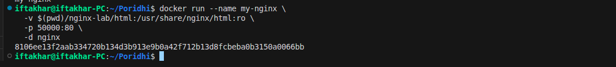

Step 5: Verify the Setup

Check Running Containers
Run the following command to confirm that the NGINX container is running:
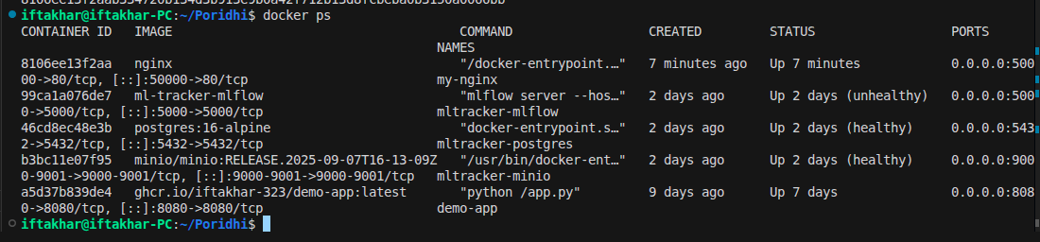

Verify that:
- The container name is my-nginx
- The status is Up
- Host port 5000 is mapped to container port 80

View the Web Page
Test the web server directly from the terminal:
curl http://localhost:50000

Expected output:
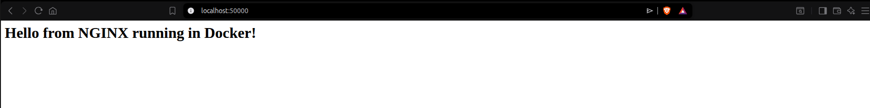

If you're using Puku CLI, you can also open the forwarded port from the Ports panel or the generated preview URL to view the page in your browser.
You should see:
Hello from NGINX running in Docker!

Managing the NGINX Container

Stop the Container
docker stop my-nginx

Start the Container Again
docker start my-nginx

View Container Logs
Display the NGINX logs:
docker logs my-nginx

Example output:
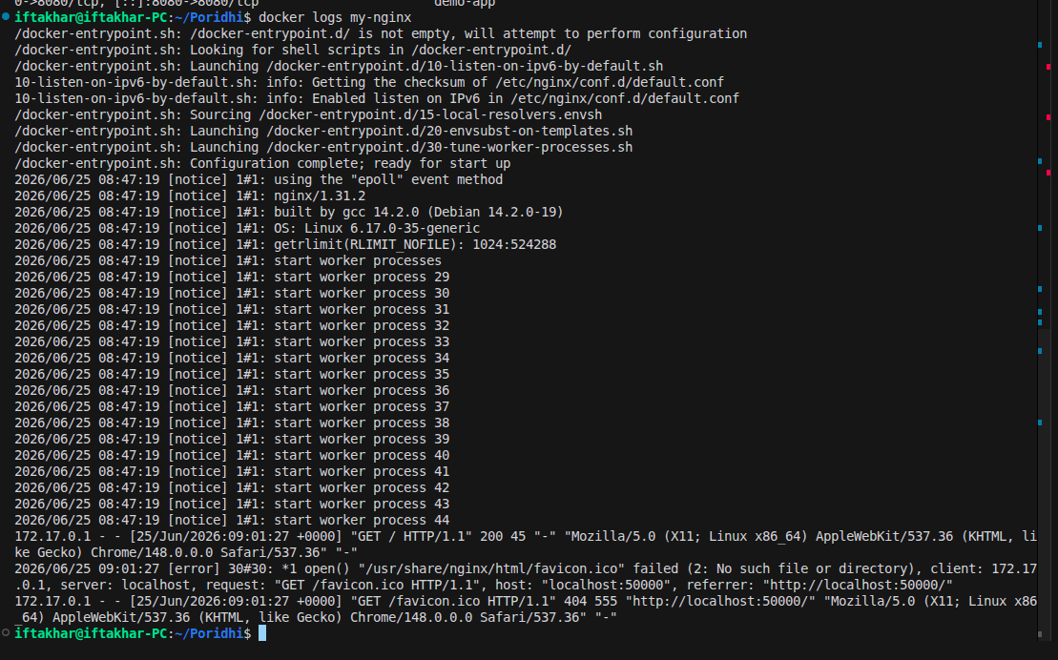

Viewing logs is useful for debugging configuration issues and monitoring the container.

Remove the Container
Once you're finished with the lab, stop and remove the container.
Stop the container:
docker stop my-nginx

Remove the container:
docker rm my-nginx

The NGINX image will remain on your system, allowing you to create new containers without downloading the image again.

Conclusion
Congratulations! 🎉
You have successfully deployed an NGINX web server inside a Docker container using Puku CLI.
Throughout this lab, you learned how to:
- Pull a Docker image from Docker Hub.
- Run an NGINX container.
- Map host ports to container ports.
- Mount a local directory to serve a custom HTML page.
- Verify that the container is running.
- Access the web server using both curl and the Puku CLI browser preview.
- View container logs for troubleshooting.
- Stop, restart, and remove Docker containers.
This exercise demonstrates how Docker provides a portable and reproducible environment for running web applications. Using Puku CLI, you can develop, test, and manage containerized applications directly from your browser without installing Docker locally.

